|  |
| --- |
| By Cliff Rodriguez |
| EC 5803 Midterm 2 |
| Due April 18, 2018 |

|  |
| --- |
| Cliff Rodriguez |

Contents

**No table of contents entries found.**

**No table of figures entries found.**

# Problem 1

1. Real business cycle models **do/don’t** suggest we use monetary policy,

Monetary policy does matter – with unanticipated and anticipated shocks to the money supply the economy responds. The impact of fiscal policy would be less clear at this time, due to the current inhabitant of the white house (does he even live there?).

How to design policy around empirical relationships is not exactly clear yet.

1. Incorporating price stickiness is the key difference between “new” and “old” Keynesian models.

New Keynesian models have

* nominal rigidities
* price setting power, or an inefficiency

This is important because it implies shocks will shift the Phillips curve, rather than an economy moving along the Phillips curve. According to new Keynesian macroeconomists say an alternative microfoundation for the world because impulse curves will only work for temporary and unexplained shocks. The new model is needed to explain that the Fed actually impacts the economy. In the data we observe that monetary policy is effective, at least to some degree.

1. The key assumption leading to an upward sloping Phillips curve in equilibrium is that prices are fully flexible. The additional aspect that is assumed is that there is a constant natural rate of unemployment. Incorporates expected prices

# Problem 2

1. Cobb-Douglas Equilibrium Share of Payments to income
$$r_{t}=αk_{t}^{α-1}$$

$$w_{t}=(1-α)k_{t}^{α}$$

2. Calibrating data is choosing parameters based on historical data or microeconomic evidence. Historically alpha has been empirically demonstrated to be 1/3.
3. The classic model does not explain what happens to wages when labor supply changes. The mathematical impact of growth in technology is not accurately modeled based on empirical evidence of world economies post 1980. The classical model is not good enough if return on capital in countries with less capital are not higher. The image below taken from the IMF shows the change in relative price of investment and the change in the labor share for countries.

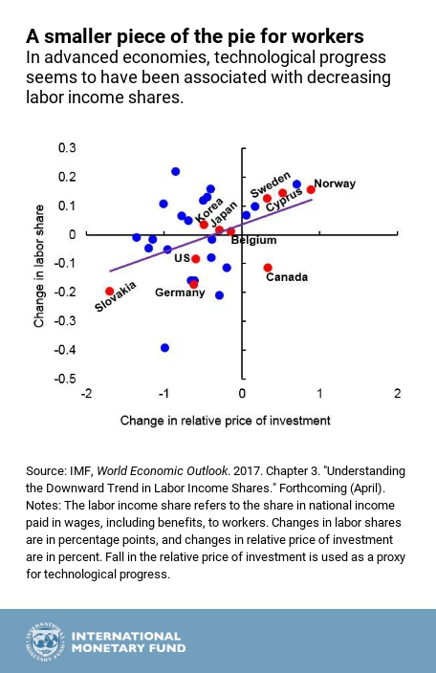

# Problem 3

1. The Social Planner setup:

$${}_{\left\{c_{t},k_{t+1},λ_{t}\right\}∞_{t=0}}^{\max{ }} \sum_{t=0}^{∞ }{β^{t}\ln\left(c_{t}\right)- λ}\left[c_{t}+ k_{t+1}- k_{t}^{α}\right]$$

The savings rate in this model will be constant. See the following:

Savings = $αβ$

1. 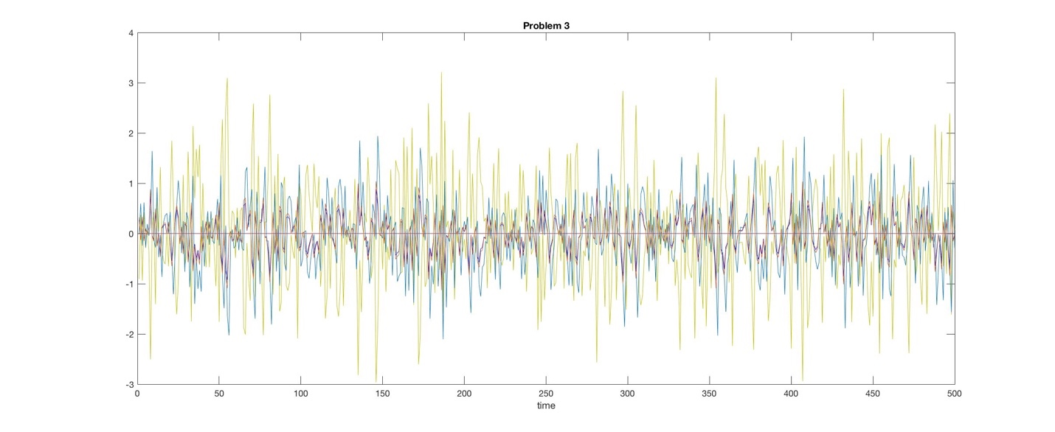

I am having issues getting a proper legend/labels to show on the plot. The legend wants to show all points in each series.

1. The difference in what is shown in part b and what we demonstrated on the homework is that in part b the fluctuations are constant, whereas the shocks we simulated on the homework resulted in a short term fluctuation with a leveling out. The intuition for the difference between the two trajectories for the same metric is that the expectations of people will level out in the homework problem and in the midterm problem there is constant re-equilibration to what is expected in the next period.

Problem 4

$\frac{u'(c_{t})}{βu'(c_{t+1})}=\left(1+i_{t}\right)\frac{P_{t}}{P_{t+1}}=marginal rate of substitution=marginal rate of transformation$

$\frac{u^{'}\left(c_{t}\right)}{βu^{'}\left(c_{t+1}\right)}=\left(1+i_{t}\right)$

1. $i_{t}=r_{t}+$;

Problem 5



Figure 2 is a Phillips curve. During the 60’s and 70’s economists were under the impression that there was only movement along a curve and the curve was policy invariant, rather than the newer vein of thought that subscribes to the idea that the curve shifts over time. The original application of the curve allowed economists to believe there was a causal and exploitable relationship between unemployment and inflation. Wanting to boost growth economists supported expansionary policy over a long duration, which lead to high inflation AND high unemployment.

